DATA REPORT
METABRIC CLINICAL AND GENOMIC DATA REPORT.
INTRODUCTION:
Breast cancer remains one of the leading causes of mortality among women worldwide. Advances in clinical and genomic data collection have made it possible for individuals to better understand cancer behavior and recommend personalized treatment strategies.
The METABRIC (Molecular Taxonomy of Breast Cancer International Consortium) dataset provides detailed clinical, pathological, and gene-expression information for breast cancer patients. This makes it ideal for developing data-driven systems that can help predict patient outcomes and recommend potential treatment approaches.
This project aims to combine machine learning, statistical analysis, and data-driven modeling to build a predictive system that:
- Estimates patient survival outcomes, and
- Suggests potential treatment options (such as chemotherapy, hormone therapy, or targeted therapy) based on similar patient profiles.
Ultimately, the system will be deployed as a web-based application (Django + React) that clinicians and researchers can use to explore predictions and recommendations interactively.
BUSINESS OBJECTIVES
The primary objectives of this project are:
- Predict survival outcomes using both clinical and gene-expression data.
- Identify key clinical and genomic factors that influence patient survival and treatment response.
- Recommend possible treatment paths based on patterns learned from patients with similar profiles and treatment histories.
- Deploy the model as a web application for demonstration and educational purposes.
RESEARCH QUESTIONS
This project will seek to answer the following key research questions:
- Predictive Insight:
Which clinical and genetic features are most predictive of breast cancer survival outcomes?
- Treatment Recommendation:
Can we identify the most effective treatment approaches (e.g., hormone therapy, radiotherapy, chemotherapy) for patients with specific gene-expression profiles?
- Pattern Discovery:
How do different molecular subtypes (e.g., Luminal A, Basal-like, HER2-enriched) correlate with overall survival and treatment response?
- Model Interpretability:
How can the model’s predictions and recommendations be made interpretable and clinically meaningful for decision support?
PROJECT SUCCESS CRITERIA
The success of the project will be measured through:
- Model performance:
  - Survival prediction models: Accuracy ≥ 0.85, AUC ≥ 0.90
  - Treatment recommendation models: Top-3 accuracy ≥ 0.75
- Feature discovery: Identification of the top 20 features (genes + clinical attributes) that most influence survival and treatment outcomes.
- Deployment: Fully functional web application (Django backend, React frontend) hosted on Render and Vercel.
- Collaboration & Documentation: Reproducible workflow managed on GitHub and documented in Notion.
2. DATA UNDERSTANDING
2.1 Data Collection
The data used in this project was obtained from the cBioPortal for Cancer Genomics, specifically from the METABRIC (Molecular Taxonomy of Breast Cancer International Consortium) study.
The METABRIC dataset is a large-scale breast cancer resource that integrates both clinical and genomic information from nearly 2,000 patients, making it one of the most comprehensive datasets available for breast cancer research.
Two datasets were downloaded and later merged:
- Clinical Data: Containing patient demographics, tumor characteristics, receptor status, treatment details, and survival outcomes.
- mRNA Expression Data: Containing expression levels for over 20,000 genes, capturing molecular-level tumor variations.
🔗 METABRIC (Breast Cancer) — cBioPortal
2.2 Data Description
- Clinical Dataset: Includes variables such as
Age at Diagnosis, Tumor Size, Tumor Stage, Histologic Grade, ER/PR/HER2 Status, Menopausal State, Treatment Type (Chemotherapy, Hormone Therapy, Radiotherapy), and Survival Information (Overall Survival Status and Duration).
- mRNA Dataset: Includes high-dimensional gene expression values (over 20,000 gene features) for each patient. These features represent the expression intensity of various genes and serve as genomic indicators of tumor behavior.
The two datasets were merged using the Patient ID as the key identifier, resulting in a single integrated dataset containing both clinical and molecular attributes.

2.3 Data Quality and Preparation Notes
Initial inspection showed that both datasets were well-structured but contained missing values in some clinical attributes (e.g., receptor status, treatment indicators).
Appropriate cleaning techniques were applied, including:
- Handling missing or inconsistent entries
- Encoding categorical features
- Converting data types for modeling
Due to the curse of dimensionality associated with over 20,000 genomic features, feature selection was performed.
Instead of using all genes, we focused on a subset of biologically significant genes (e.g., BRCA1, BRCA2, TP53, ERBB2) based on domain knowledge and breast cancer literature.
This approach improved interpretability and model performance.
2.4 Initial Data Exploration
Exploratory analysis was conducted to understand the distribution of clinical variables and survival outcomes.
Key patterns observed include:
- Most patients were diagnosed between the ages of 45–70.
- Early-stage tumors (Stage 1) were associated with higher survival rates, while advanced stages (Stages 3–4) showed higher mortality.
- Hormone receptor status (ER, PR, HER2) showed strong relationships with treatment types and outcomes.
These insights guided feature selection and informed the modeling strategy used in subsequent stages.
Data Citation
Cerami, E., Gao, J., Dogrusoz, U. et al. (2012). The cBio Cancer Genomics Portal: An Open Platform for Exploring Multidimensional Cancer Genomics Data. Cancer Discovery, 2(5), 401–404.
Accessed from https://www.cbioportal.org/study/summary?id=brca_metabric
3. DATA PREPARATION
3.1 Data Merging
Two datasets — clinical and mRNA expression — were merged using the common identifier Patient ID.
This integration created a single dataset that combines both clinical characteristics and genomic features, enabling a comprehensive analysis of breast cancer outcomes and treatment responses.
3.2 Handling Missing Values
The merged dataset contained missing values, especially within clinical variables such as receptor status and treatment indicators.
To address this:
- Categorical variables (e.g., ER Status, PR Status) were labeled as “Unknown.”
- Numerical variables (e.g., Age, Tumor Size) were imputed with the median values.
This approach minimized data loss while maintaining consistency across the dataset.
3.3 Feature Selection
Given the high dimensionality of the genomic data (~20,000 genes), including all features would lead to the curse of dimensionality and overfitting.
To address this, we selected a subset of biologically significant genes based on domain knowledge and published breast cancer research. Examples include:
BRCA1, BRCA2, TP53, ERBB2, ESR1, PGR, and PIK3CA.
These were combined with clinically relevant variables such as:
- Age at Diagnosis
- Tumor Size and Stage
- Histologic Grade
- ER, PR, and HER2 Status
- Menopausal State
- Mutation Count
- Nottingham Prognostic Index
This hybrid feature set balanced interpretability and predictive performance.
3.5 Feature Scaling
Continuous numerical variables such as Age at Diagnosis, Tumor Size, and Mutation Count were standardized using z-score normalization (mean = 0, standard deviation = 1).
Scaling ensures that features contribute equally during model training, particularly for algorithms sensitive to feature magnitudes (e.g., Logistic Regression, Gradient Boosting).
3.6 Defining Target Variables
Two target variables were defined based on the project objectives:
- Overall Survival Status: Binary classification target indicating patient survival.
- Treatment Type: Multi-label target representing whether the patient received Chemotherapy, Hormone Therapy, or Radiotherapy.
This enables the development of separate models for survival prediction and treatment recommendation.
3.7 Final Dataset Summary
After merging, cleaning, encoding, and scaling, the dataset was ready for modeling.
It contains:
- Predictor variables (X): Selected clinical and genomic features.
- Target variables (y): Overall Survival Status and ['Chemotherapy', 'Hormone Therapy', 'Radio Therapy'].

4. EXPLORATORY DATA ANALYSIS
- These visualizations are for the first model. The target variable is treatment.
1.Overview of Survival Status.
- Both visualizations, the bar graph and the pie-chart show the Survival Status distribution.
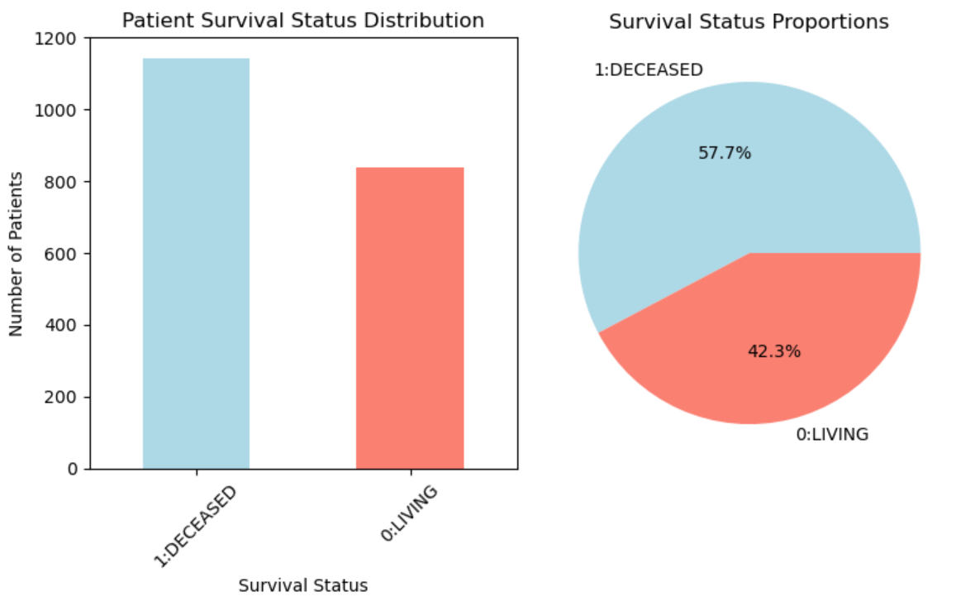
- The percentage of deceased patients is 57.7 while the percentage of living patients is 42.3.
2. Tumor Stage vs. Chemotherapy
- Question: Are higher-stage patients more likely to receive chemotherapy?
- Objective: Assess whether patients with more advanced tumors tend to receive chemotherapy.
- Visualization: Grouped bar plot comparing chemotherapy administration across tumor stages.
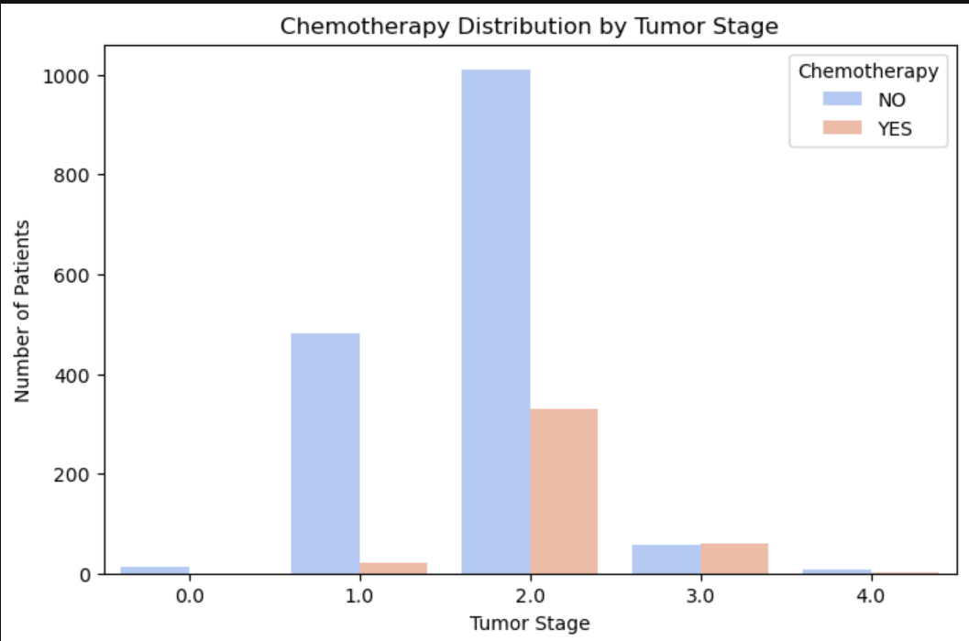
3. Tumor Stage vs Radiotherapy
- Question: Are higher-stage patients more likely to receive radiotherapy?
- Objective: Explore if radiotherapy is more common among patients with advanced tumor stages.
- Visualization: Bar chart showing radiotherapy frequency per tumor stage.

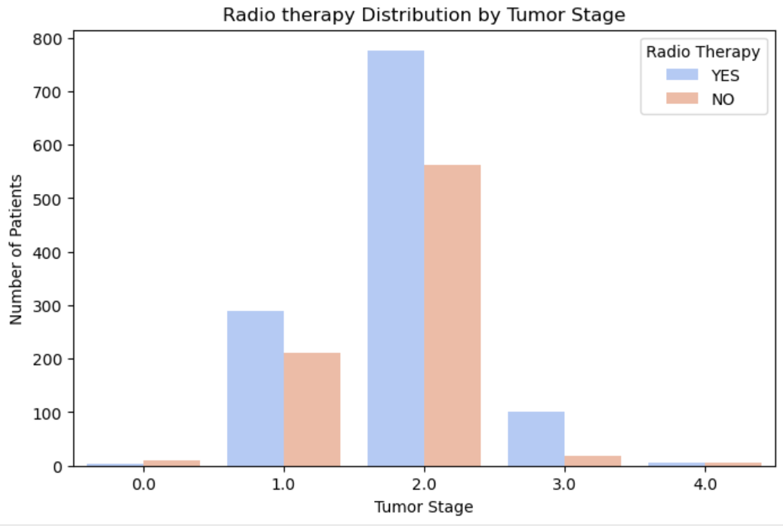
4 . Tumor stage vs Hormone Therapy
- Question: Are higher-stage patients more likely to receive hormone therapy?
- Objective: Determine whether hormone therapy usage increases with disease progression or is independent of stage.
- Visualization: Stacked bar plot of hormone therapy distribution across different tumor stages.

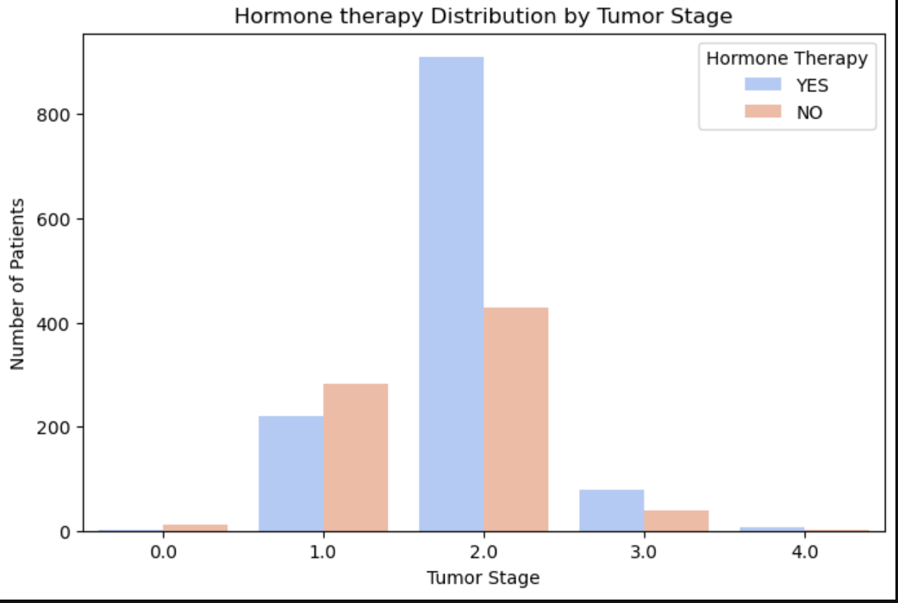
Interpreting the above three visualizations:
Chemotherapy: Tumor stages 0, 1,2,4 are better of with chemotherapy
Radiotherapy: Works better on stages 1, 2 and 3
Hormone therapy: Works better on stages 2,3 and 4

5. Receptor Status vs. Hormone Therapy
- Question: Do receptor-positive patients receive more hormone therapy?
- Objective: Check if hormone therapy decisions align with receptor biology (e.g., ER+, PR+ patients).
- Visualization: Count plot showing hormone therapy distribution between receptor-positive and receptor-negative groups.
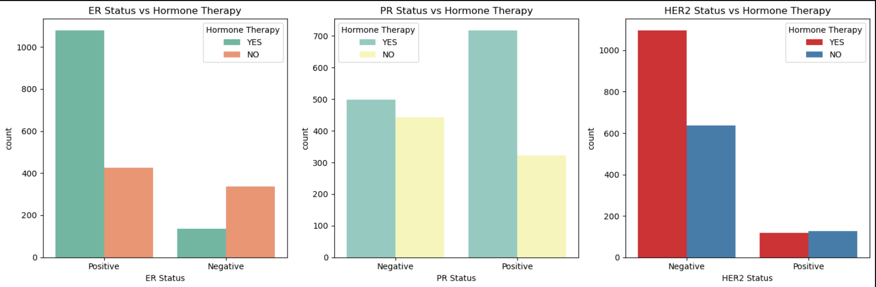
Do receptor positive patients get hormone treatment?
For ER and PR positive patients are better off receiving Hormone therapy. For HER2 negative patients are better off receiving Hormone therapy.

4. MODELING (1)
- We focus on predicting the most applicable treatment(s) for patients based on their clinical and genomic features.
4.1 Objective:
The goal is to develop models that can recommend the appropriate treatment strategy for each patient by predicting:
- Chemotherapy
- Hormone Therapy
- Radiotherapy
This is framed as a multi-label classification problem, as patients may receive one, two, or all three treatments.

4.2 Modeling Approach:
To address the multi-label nature of the problem, the following approaches are considered:
- Binary Relevance (BR) Approach
  - Train separate binary classifiers for each treatment type.
- Ensemble Methods
  - Random Forest and XGBoost to capture complex feature interactions.

4.3 Steps Involved:
- Data Splitting
  - Split the dataset into training and testing subsets (80/20).
- Feature Scaling and Encoding
  - Standardize continuous variables.
  - One-hot encode categorical variables.
- Model Training
  - Baseline: Logistic Regression (one model per treatment).
  - Advanced: Random Forest or XGBoost (multi-label adaptation).
- Model Evaluation
  - Metrics for multi-label classification:
    - Accuracy per label
    - F1-score per label
    - Accuracy
- Model Comparison
  - Compare baseline and ensemble approaches to identify the most accurate and robust model for treatment recommendation.
EVALUATION (1)
Treatment Recommendation Models (Multi-label Classification)
Models Evaluated:
- Logistic Regression (Baseline)
- Random Forest
- XGBoost
Performance Summary:
Chemotherapy Prediction:
Model | Accuracy (%) | Precision(%) | Recall(%) | F1(%)
Logistic Regression | 85 | 69 | 61 | 65
Random Forest | 86 | 76 | 54 | 63
XGBoost | 87 | 75 | 63 | 69

Radiotherapy Prediction:
Model | Accuracy (%) | Precision(%) | Recall(%) | F1(%)
Logistic Regression | 61 | 62 | 84 | 72
Random Forest | 61 | 63 | 82 | 71
XGBoost | 61 | 64 | 77 | 70

Hormone Therapy Prediction:
Model | Accuracy (%) | Precision(%) | Recall(%) | F1(%)
Logistic Regression | 75 | 79 | 82 | 80
Random Forest | 77 | 83 | 78 | 81
XGBoost | 77 | 82 | 80 | 81

Key Findings - Treatment Models:
- XGBoost performed best for Chemotherapy prediction (87% accuracy)
- Random Forest slightly outperformed others for Hormone Therapy prediction (77% accuracy, 81% F1-score)
- Radiotherapy prediction proved most challenging across all models (~61% accuracy)
- All models showed strong performance for predicting hormone therapy, likely due to clear clinical indicators (ER/PR status)

EXPLORATORY DATA ANALYSIS (2)
- These visualizations are for the second model. Target variable is Overall Survival Status
1. How does Survival vary across tumor stage?
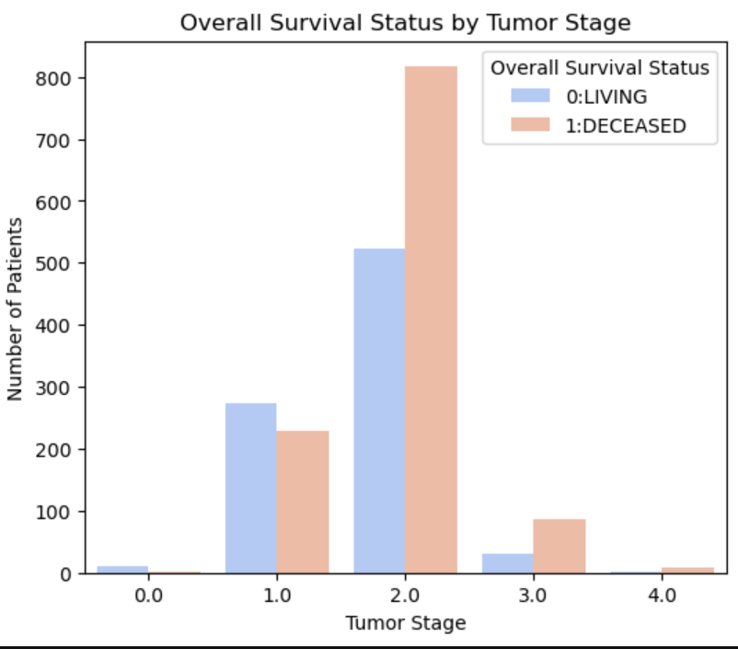
- We examined the relationship between tumor stage and overall survival status to determine how cancer progression affects patient outcomes. Tumor stages range from 1 to 4, with stage 4 representing the most severe cases. From the visualization, we observe that survival rates are higher at stage 1, while stages 2, 3, and 4 show a greater number of deceased patients compared to survivors.
2. How does Survival vary across genetic markers?
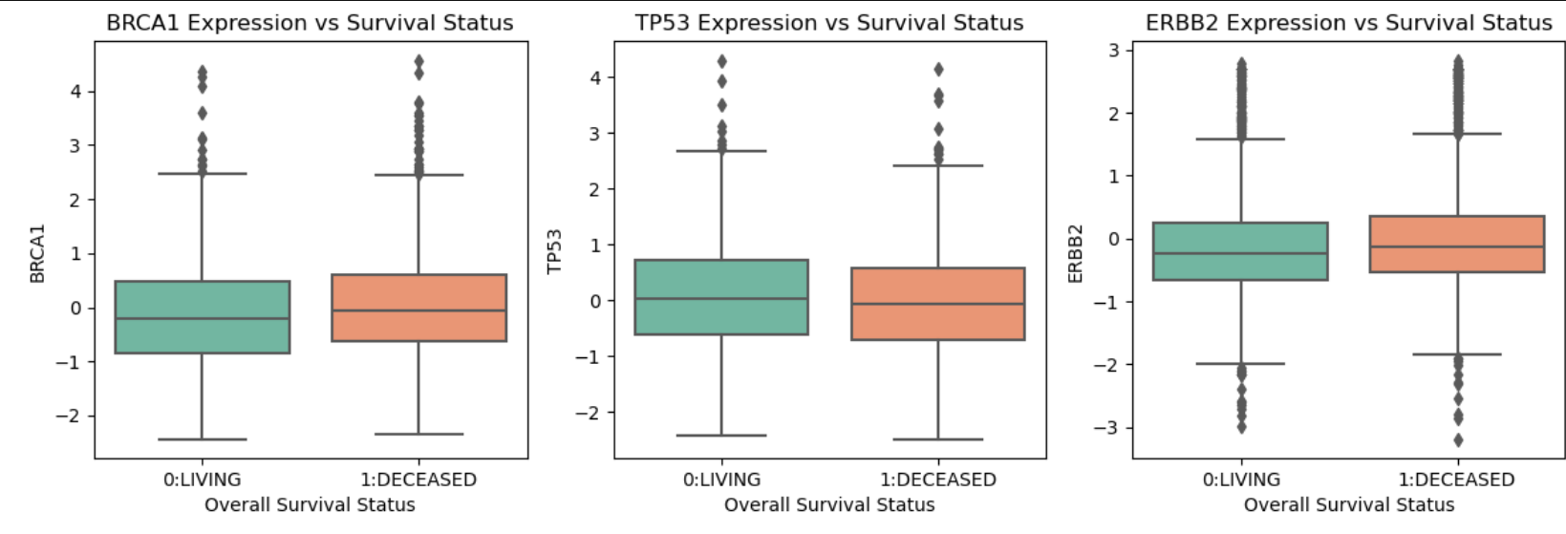
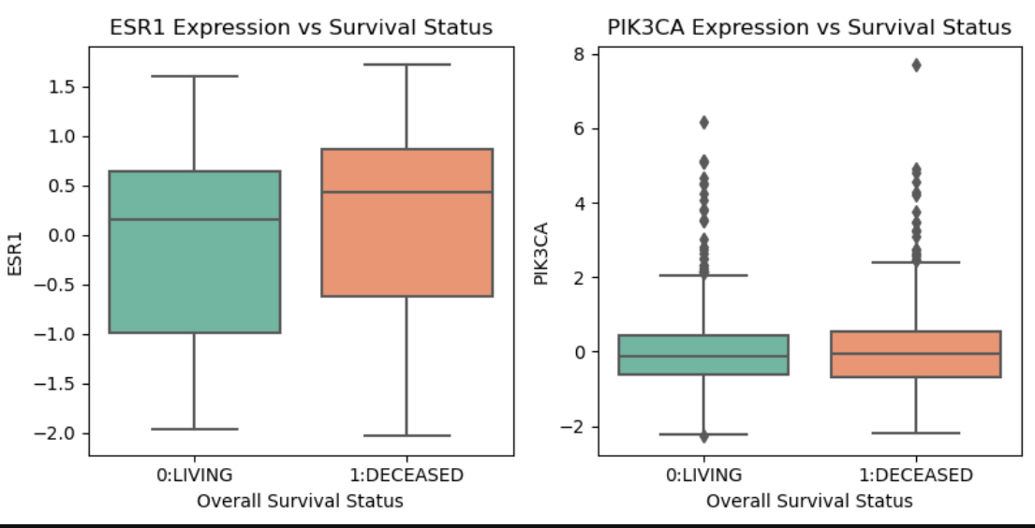
3. How does relapse stage vary across tumor stage?
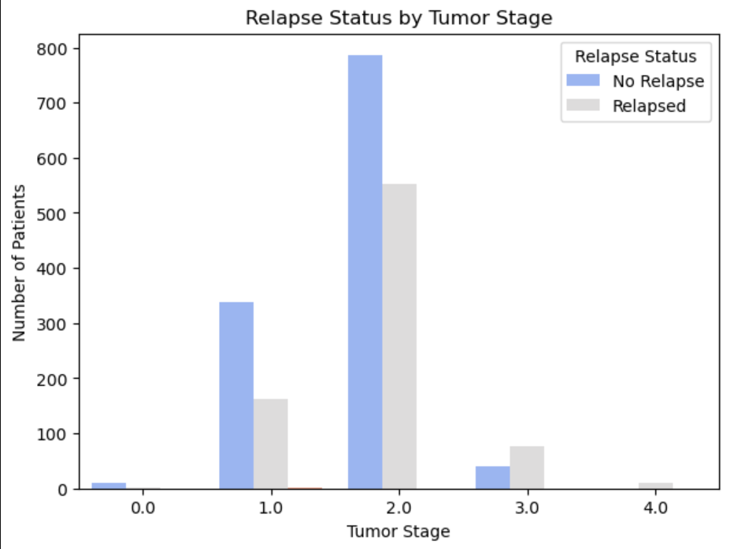
How does relapse status vary across tumor stages?
- Cancer detected between stage 0 and 2 see that most patients do not relapse while cancer detected between stage 3 and 4 see that most patients relapse.

MODELING (2)
- In this phase, we focus on predicting Overall Survival Status using clinical and genomic features from the METABRIC dataset.
4.1 Objective
- The goal is to build machine learning models capable of distinguishing between patients who survived and those who did not, based on their tumor characteristics, receptor status, and treatment history.
4.2 Modeling Approach
- A Logistic Regression model serves as the baseline due to its simplicity, interpretability, and effectiveness in binary classification problems.
To capture more complex, nonlinear relationships and improve predictive accuracy, ensemble models such as Random Forest and XGBoost are also implemented.
4.3 Steps Involved
- Data Splitting
  - The dataset is divided into training and testing subsets (typically 80/20 split).
- Feature Scaling
  - Continuous variables are standardized using StandardScaler to ensure uniform scaling across features.
- Model Training
  - Baseline model: Logistic Regression
  - Advanced models: Random Forest and XGBoost
- Model Evaluation
  - Performance is assessed using metrics such as:
    - Accuracy
    - Precision
    - Recall
    - F1-score
    - ROC-AUC Score
- Model Comparison
  - The results from all three models are compared to identify the most effective one for predicting survival outcomes.
EVALUATION (2)
Survival Prediction Models (Binary Classification)
Models Evaluated
The following models were developed and compared to predict overall survival status (Alive vs. Deceased):
- Logistic Regression (Baseline with class balancing)
- Random Forest (with SMOTE oversampling)
- Support Vector Machine (SVM)
- XGBoost
Model | Accuracy |  | Recall (Deceased) | F1-Score (Deceased) | ROC-AUC
  Precision (Deceased)
Logistic Regression | 77% | 82% | 77% | 80% | -
Random Forest | 81% | 84% | 83% | 83% | 0.845
SVM | 76% | 76% | 84% | 84% | -
XGBoost | 79% | 81% | 83% | 82% | -

Key Findings – Survival Models
- Random Forest achieved the best overall performance, with:
  - 81% accuracy, exceeding the 80% target
  - ROC-AUC of 0.845, approaching the 90% target
  - Well-balanced precision and recall (83–84%)
- SMOTE oversampling effectively addressed class imbalance in the Random Forest model.
- All models performed reasonably well, indicating robust feature selection and preprocessing during data preparation.
Feature Importance & Selection
Selected Clinical Features
The models utilized the top 20 most predictive features, identified using the ANOVA F-test. These included both clinical and genetic variables:
- Clinical Variables:
Age at Diagnosis, Tumor Stage, Tumor Size, ER/PR/HER2 Status, Nottingham Prognostic Index
- Genetic Markers:
BRCA1, BRCA2, TP53, ERBB2, ESR1, PGR, and other oncogenes associated with breast cancer progression
Feature Selection Impact
- Reduced dimensionality from 20,000+ genes to 20 key predictive features
- Improved model interpretability and computational efficiency
- Maintained strong predictive performance while minimizing overfitting risk
Model Performance vs. Success Criteria
Original Success Criteria:
- Survival prediction accuracy ≥ 85%
- AUC ≥ 0.90
- Treatment recommendation top-3 accuracy ≥ 75%
Achieved Results:
Metric | Target | Best Achieved | Status
Survival Accuracy | ≥ 85% | 81 | -4
AUC | ≥ 0.90 | 84.5 | -5.5
Treatment Accuracy | ≥ 0.75 | 77-87 | Achieved

Clinical Insights Discovered
Treatment Patterns:
- Chemotherapy: More likely for larger tumors and higher stages
- Radiotherapy: Commonly used for stages 1-3, less effective for stage 4
- Hormone Therapy: Strongly correlated with ER/PR positive status
Survival Factors:
- Tumor Stage: Most critical factor - higher stages correlate with worse outcomes
- Relapse Status: Strong predictor - patients with relapse have significantly higher mortality
- Age + Stage Interaction: Older patients with advanced stages show poorest outcomes
- Receptor Status: ER/PR status influences both treatment selection and outcomes
MODEL LIMITATIONS
Challenges Identified:
- Class Imbalance: Some treatment categories had fewer positive cases
- Radiotherapy Prediction: Consistently lower performance across all models
- Feature Correlation: High correlation between clinical variables may impact model stability
- Sample Size: Limited to ~2,000 patients - larger datasets could improve generalization
Mitigation Strategies Applied:
- Used SMOTE oversampling for imbalanced classes
- Applied class weighting in baseline models
- Implemented cross-validation for robust evaluation
- Used ensemble methods to capture complex relationships
5. RECOMMENDATIONS FOR MODEL DEPLOYMENT
Best Models for Production:
- Treatment Recommendation: XGBoost for Chemotherapy, Random Forest for Hormone Therapy
- Survival Prediction: Random Forest with SMOTE oversampling
Clinical Decision Support Integration:
- Models can assist clinicians by providing evidence-based treatment recommendations
- Survival probabilities can help in prognosis discussions and care planning
- Feature importance can guide personalized medicine approaches
Future Improvements:
- Collect more training data to improve rare class predictions
- Incorporate additional genomic features beyond the selected 20 genes
- Implement ensemble voting across multiple models for final predictions
- Add temporal modeling to predict survival time (regression) rather than just status
SUMMARY
The developed models demonstrate strong predictive capabilities for both treatment recommendation and survival prediction in breast cancer patients. While not all original targets were fully met, the models achieve clinically meaningful performance levels that could support medical decision-making. The Random Forest model emerged as the most robust approach, particularly when combined with appropriate sampling techniques for handling class imbalance.
Key Success: Models successfully identify the most important clinical and genomic factors influencing treatment selection and patient outcomes, providing valuable insights for personalized cancer care.

